**Examples of Yield Plots and Trial Design Plots found in Papers Cited in DIFM Zotero Page**

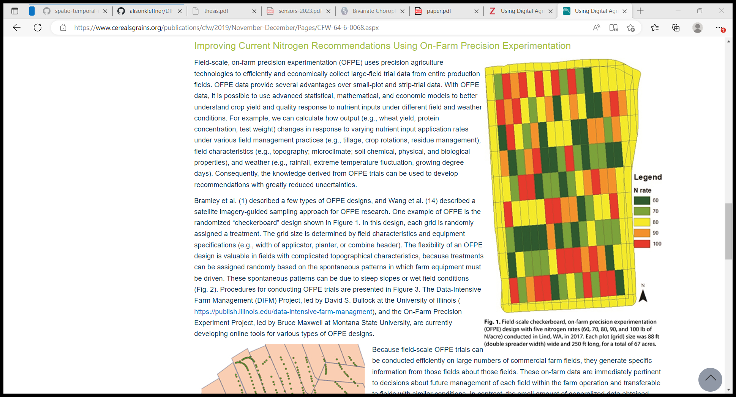**Example 1:** Using Digital Agriculture Technologies to Improve Nitrogen Management and Wheat Yield (Tao and Bullock, 2019) – Figure 1

* Prescription map color

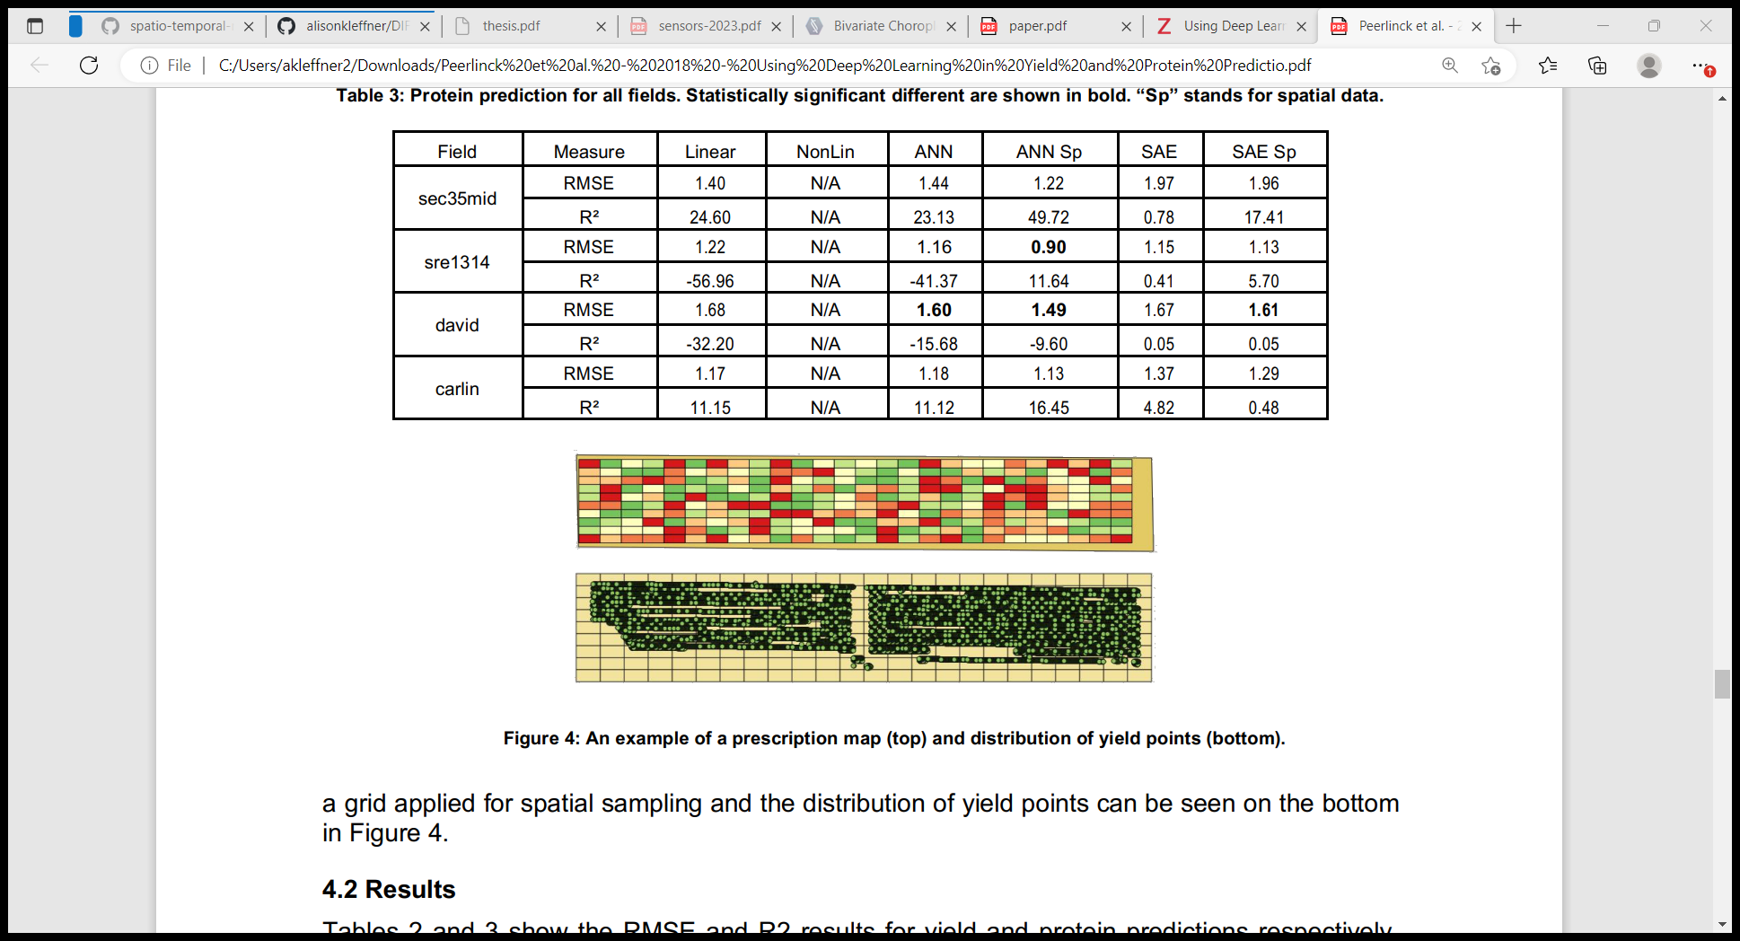**Example 2:** Using Deep Learning in Yield and Protein Prediction of Winter Wheat Based on Fertilization Prescriptions in Precision Agriculture (Peerlinck et al, 2018)

* Overlapping yield points (just showing distribution) – have no idea of number.
* Looks like a black outline around each point (probably a better way to show the distribution)
* Colors of prescription map – all of Amy’s paper seem consistent with this color scheme for the prescription map
* Using green for yield points and in prescription map

**Example 3:** Rationale for field-specific on-farm precision experimentation (Hegedus & Maxwell, 2022)

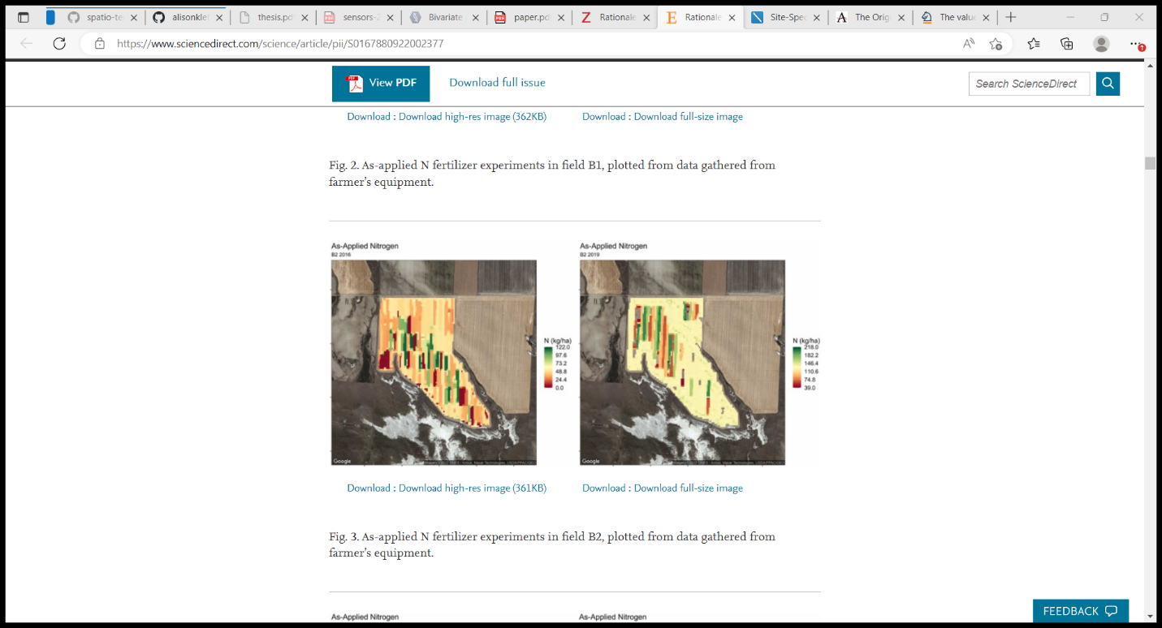

* Color Scheme (red-yellow-green = bad)
* Should use a sequential color scheme instead since just showing magnitude.

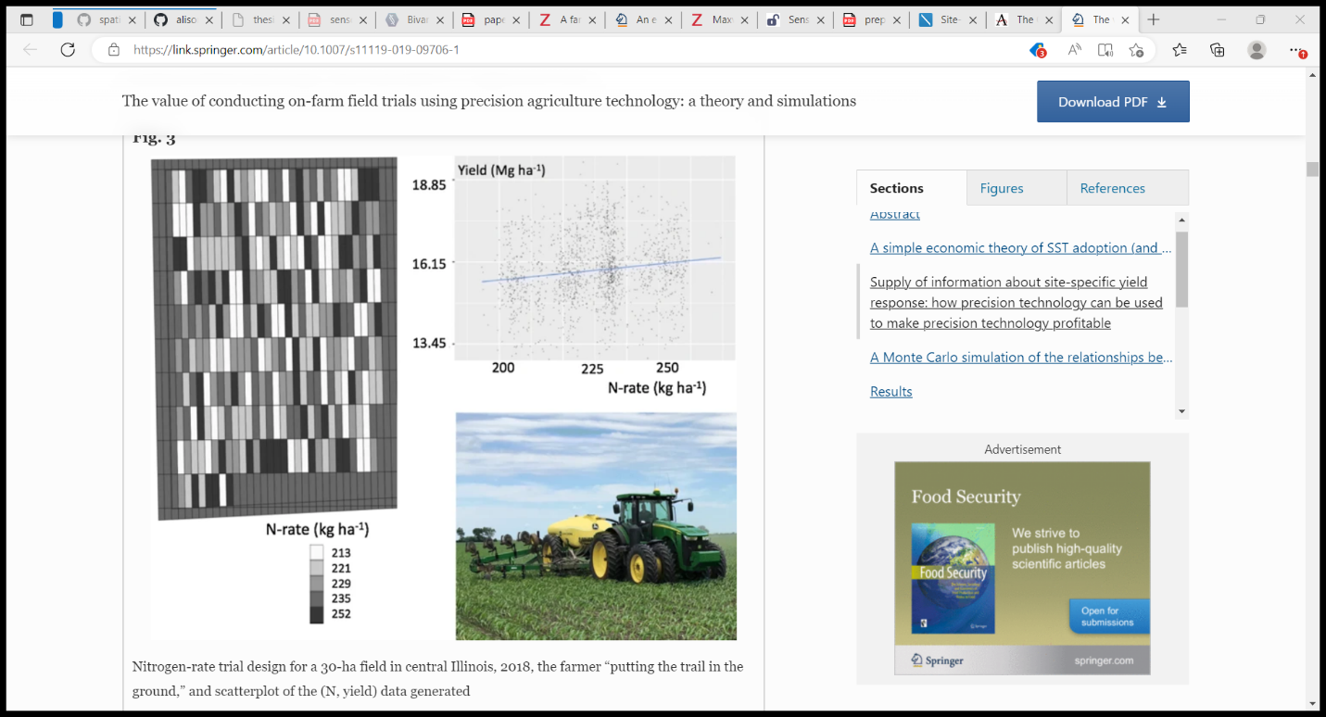**Example 4:** The value of conducting on-farm field trials using precision agriculture technology: a theory and simulations (Bullock et al, 2020)

* Lose spatial location in the yield data, so can’ really associate between the trial design and the yield scatterplot (idk if this one is relevant)

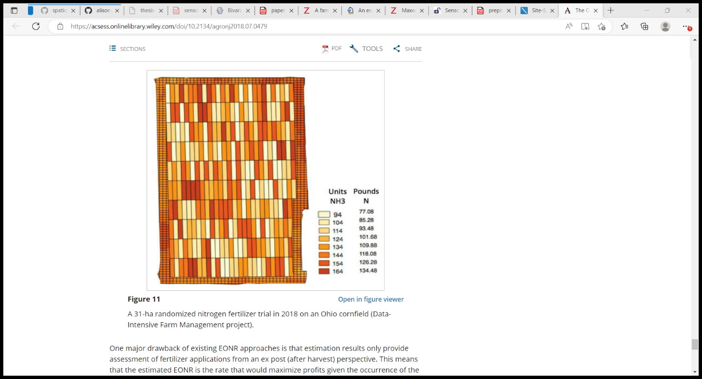**Example 5:** The Origins, Implications, and Consequences of Yield-Based Nitrogen Fertilizer Management (Rodriguez et al, 2019)

* Nothing super wrong, just inconsistent with other nitrogen trial designs, and close to the color that has been used previously for yield.
* Units and lbs should be lined up more.

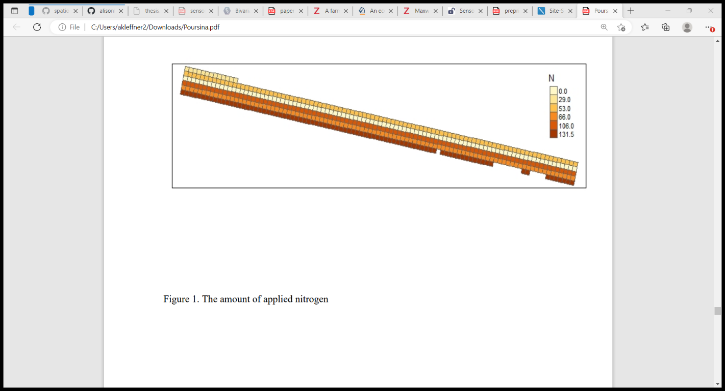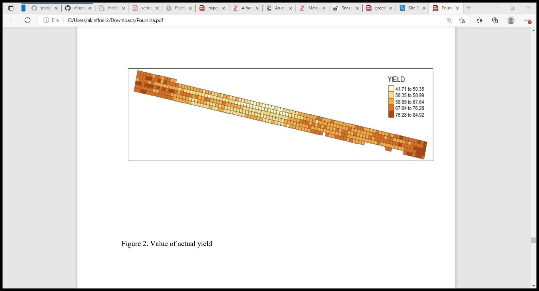**Example 6:** Site-Specific Nitrogen Recommendation: Using Bayesian Kriging with Different Correlation Matrices (Poursina & Brorsen, 2021)

* Same colors used for Nitrogen and Yield (confusing) – Figure 1 and Figure 2 respectively

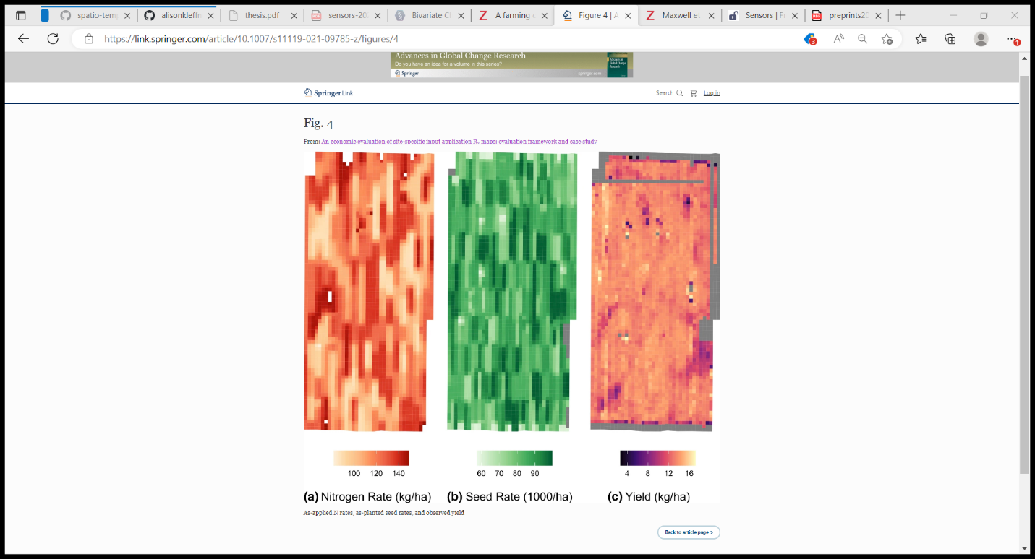**Example 7:** An Economic Evaluation of Site-Specific Input Application Rx Maps: Evaluation Framework and Case Study (Gardner et al, 2021) – Figure 4

* Color schemes for nitrogen and yield not consistent with other DIFM papers
* A lot to ask the user to compare among the three figures – lots of mental effort
* Different color scheme for yield
  + Should be sequential
  + Overlapping color between yield and nitrogen colors – both have orange/red/yellow

**Example 8:** Can Optimization Associated with On-Farm Experimentation Using Site-Specific Technologies Improve Produce Management Decisions? (Maxwell et al, 2018) – Figure 2 (RHS)

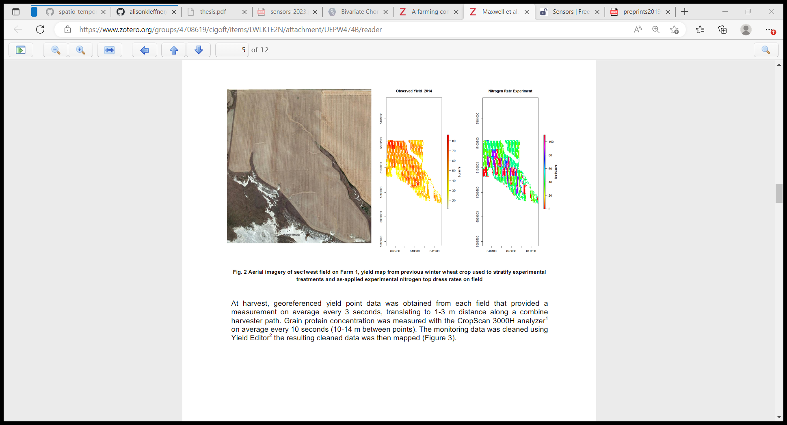

* Nitrogen Experiment color scheme is rainbow – not perceptually optimal
  + Also looks like it kind of both begins and ends with a reddish color

**Example 9:** Spatial variability of crop responses to agronomic inputs in on-farm precision experimentation (Trevisan et al, 2021)

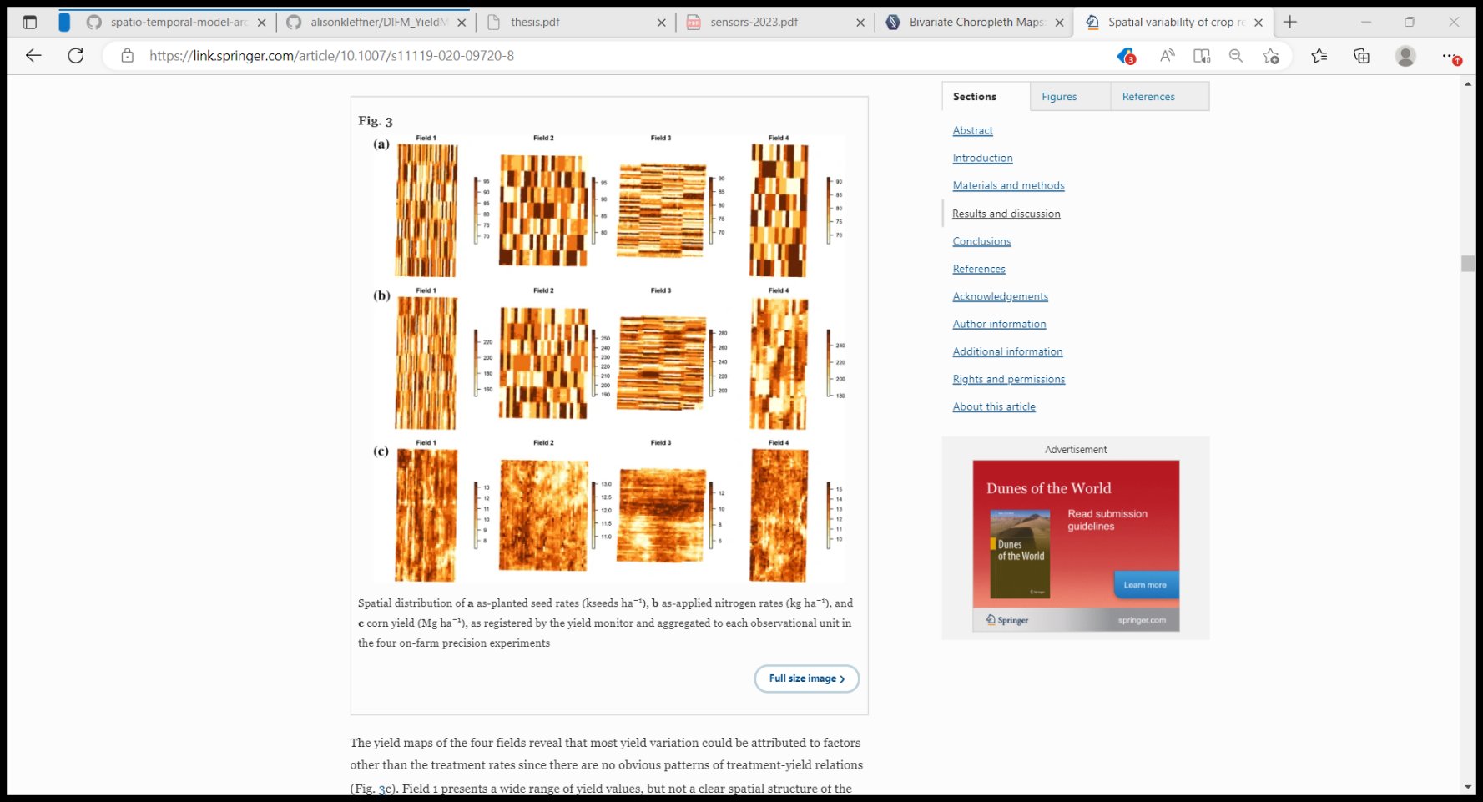

* Same color for both trial designs and yield maps